Nicholas Hopkins
British, b.

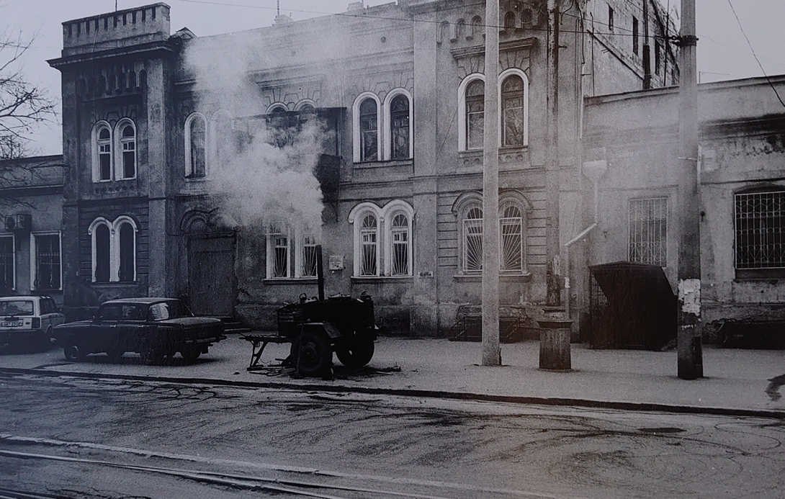

Nicholas Hopkins has been taking pictures continuously over the past 20 years and has an archive of over 20,000 images. He is self-taught and enjoys distilling striking images from everyday scenes. Hopkins uses little equipment; just a simple mechanical camera (a 35mm range finder) with a standard lens, almost all images taken hand-held. He always uses natural light and takes un-staged photographs. Each image is hand printed and treated with selenium to prevent fading.
Hopkins takes advantage of varied weather conditions to bring out the textures of his subject matter, either profiting from clear sharp days to maximise detail and contrast, or, especially in city scenes, using rain to let reflections shine off the tarmac or off cars and trains.
Although contemporary in subject matter Hopkins’ photographs are redolent of the 1950s and have a cinematic quality. Amongst his influences he names the German photographers August Sander (1876 – 1964) and Albert Renger Patzsch (1897 – 1966).
In his city scenes, Hopkins captures still moments against busy urban backgrounds. Deep focus enables the subject and the surroundings to be seen in equal detail thus recording the minutiae of a city's everyday life.
In the countryside, he concentrates on the forms and patterns that are to be found in nature. Hopkins instinctively notes compositions that convey a feeling of space or emotion.
Locations for photographs include New York, California, Estonia and Latvia, London, Suffolk, Poland, Ukraine, Andalusia, Germany, Portugal, and Vienna.

Selected Solo Exhibitions
2023 Memories of Odesa, Fiumano Clase, London
2004 Roadscapes and Railways – Manmade Landscapes, Shell Centre, London
2003 Loitering with Intent, Bolands, London

Selected Mixed Exhibitions
2016 Contrast, Fiumano Projects, London
Editions, Orion Contemporary, London
2015 The Poetics of Space, Safehouse 1, London
The Exchange Gallery, Saffron Walden Library, Saffron Walden, Essex
2014 Blacks Private Members Club, London
Phoenix Café, London
2009 What Happens after the Ball, Piccadilly, London
Kunst Ohne Grenzen Gallery, Berlin
2007-2016 Lavenham Open Studios, Suffolk
2005 Kinky Kalinky – Film and Video Work
Nihilism, Decima Gallery, London
1995 Obscure Angles of Desire (16mm film, duration 5 min) Battersea Film Festival
1994 La Grande Fumee (8mm film, duration 28 mins), Battersea Film Festival, London

