LUCY SMALLBONE: EDGELANDS
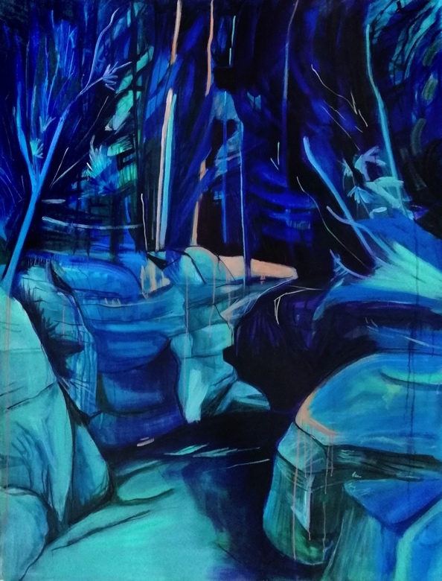
25 October – 15 December 2018
Lucy Smallbone, Blue Vista, Oil on Canvas, 150 x 125cm, 2018
British Artist Lucy Smallbone’s second ever solo exhibition, Edgelands, opens to the public on 25 October and runs until 15 December 2018 at Fiumano Clase, Unit 12, 21 Wren Street, London WC1X 0HF.
Lucy Smallbone, Blue Vista, Oil on Canvas, 150 x 125cm, 2018

Smallbone specialises in modern landscape painting and creates works which investigate the effect of memory in altering our perceptions of a place. She uses bold colour and abstract form to merge fictional and real spaces, creating vivid yet distorted images. The title for the exhibition, ‘Edgelands’, describes the transitional, liminal areas of space to be found on the boundaries between man-made and natural environments. Smallbone uses “this feeling of never truly having access to the landscape to reflect something that is felt in moments of the sublime in nature.”
She started her education at Falmouth with a foundation diploma in Art and Design. Then after receiving a 1st class degree in painting from City and Guilds of London Institute, Smallbone went on to complete a masters at the Slade School of Fine Art where she won several awards for her work, including the Duveen Travel Prize in 2015. The travel prize enabled Smallbone to visit Chernobyl, Ukraine, which became a huge influence on her work.

There is something unusual about Smallbone’s paintings which she describes as “beautiful with something not quite right about them”. Informed by her recent visit to Chernobyl, Smallbone’s works bridge this uneasy gap- where, despite the lasting contamination of the area, scientists have been surprised by the dramatic revival of its wildlife. Abandoned man-made structures are juxtaposed with natural forms to create intriguing yet uneasy landscapes.

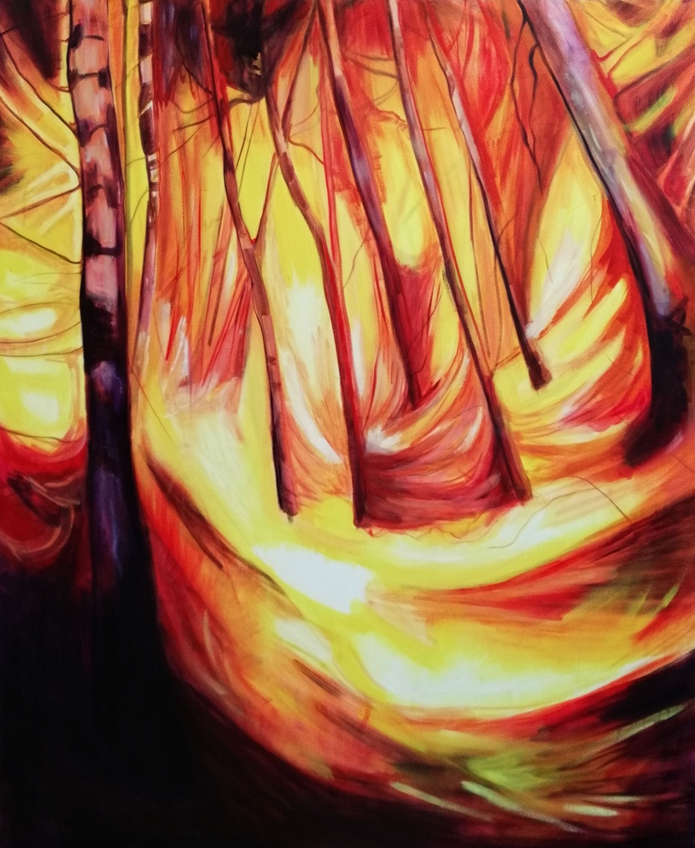
Smallbone tends to work with oil paint on board; the rigidity of the board’s surface is less forgiving than canvas and allows for much more direct marks. Her paintings vary in size as Smallbone suggests there is “something interesting about painting something monumental on a small scale”.

Inspired by the time she spent in the red forest in Chernobyl, Smallbone describes her paintings, “The red forest is the most radioactive area in the Zone and was physically burnt red by the contamination. In the work the fire like the radiation consumes and flattens the space making it hard for the viewer to access it, this was similar to my own experience of being in the red forest."

Edgelands at Fiumano Clase will coincide with Lucy Smallbone’s HSBC exhibition in Canary Wharf at the end of the year.
Lucy Smallbone, Fire, Oil on Canvas, 150 x 125cm, 2018
Lucy Smallbone: Edgelands
Exhibition: 25th October – 15th December 2018
Private View: 24th October 2018
https://www.lucysmallbone.com

Fiumano Clase
Unit 12
21 Wren Street
London WC1X 0HF
https://www.fiumanoclase.com

